**PROJECT REPORT**

CHARTING THE COURES OF INNOVATION AND STARTUP PERFORMANCE ANALYSIS

INTRODUCTION:

**1.Overview**

Charting the course of innovation and start up performance analysis is the project that help the beginner business man to achieve new innovative method to take up there new business to high level .

**2.Purpose**

This project help the person to know about the overview of their own business ,they can identify how to take up the new inventions on their business for their further development . It bring the analysing of their profit and their losses

**PROBLEM DEFINITION AND DESIGN THINKING**

**2.1 Empathy map**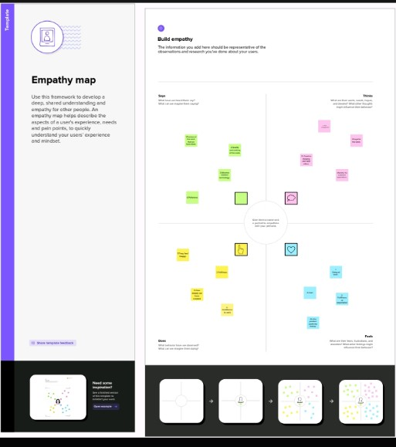

**2.2 Ideation & Brainstorming Map**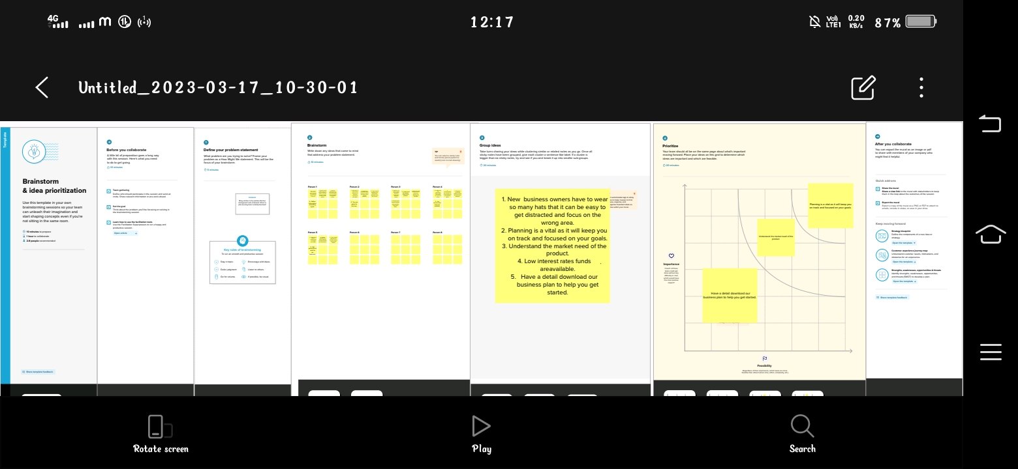

**RESULT**

Project output screen shot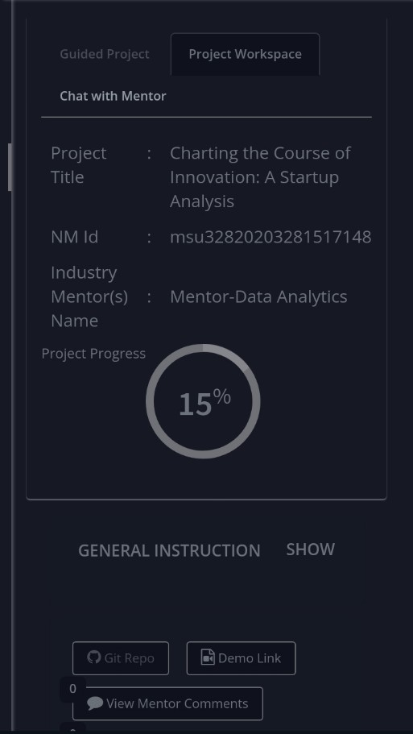

**ADVANTAGES &DISADVANTAGES**

**Advantages :**

1.It provide creative thinking for the business.

2. we can satisfy the customers expectation by analysing.

3.we can manage the cost

4. It provide confidence to our work

5.We can implement the modern technology

6. Data makes the work easy

**Disadvantages** :

1.Time management is hard

2.In case of lack of data it is harder to due the work

**APPLICATIONS**

1.In new business

2.To correct the analysis of the data

3.Marketing

4.Business dealings

5. Startup programs

**CONCLUSION**

**FUTURE SCOPE**

**APPENDIS**